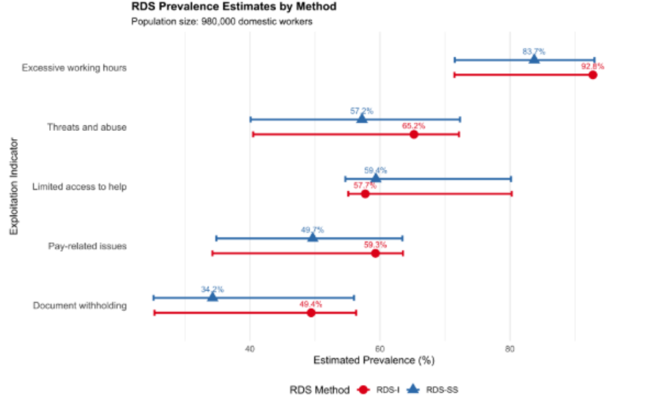
Figure 5 Forest Plot of RDS Estimates: Comparison of RDS-I and RDS-SS prevalence estimates for binary exploitation indicators (N=980,000). Error bars represent 95% bootstrap confidence intervals. Source: Authors’ Own Work.

